# Abstract

Predicting the effective price of shares inside the stock exchange is becoming extremely relevant, as the benefits and risks vary greatly, but both financial firms and government regulators pay serious attention to it. Several analysts attempted to forecast the stock's value in the early period. Equity has long been chosen as an investment portfolio strategy by traders due to its high profits. The primary goal of this research is to explore whether machine learning can reliably forecast stock market performance to some extent. In this study it provide a very accurate system for forecasting future stock prices and stock price movement tendencies. The prediction model is composed of eight distinct machine-learning approaches, including two distinct classification and regression models. The forecasting framework includes two deep-learning regression models in addition to an LSTM network and numerous convolutional neural networks (CNNs).

Table of Contents

Abstract 2

Chapter 1: Introduction 6

1.1 Research Background 6

1.2 Problem Statement 7

1.3 Research Questions 7

1.4 Aims and Objectives 8

1.5 Scope 8

1.6 Rationale 8

1.7 Structure of the research 9

Chapter 2: Literature Review 10

2.1 Stock prediction via continuous and binary data 10

2.2 Use of classifiers and social media news for protecting the stock market 11

2.3 Predicting the stock closing price 13

2.4 Comparing deep learning algorithms and machine learning algorithms for stock prediction 14

2.5 Different models and methods for implementing the stock market predictions 15

2.6 Investment Strategies for the stock market based on predictions 17

2.7 A generative adversarial network for stock prediction method 18

Chapter 3: Methodology 20

3.1 Research Philosophy 20

3.2 Research Approach 21

3.3 Research Strategy 21

3.4 Research Choice 22

3.5 Data gathering and analysis 23

3.6 Research procedures & techniques 23

Chapter 4: Result 25

Chapter 5 Discussion 30

Chapter 6: Conclusion & Recommendation 34

6.1 Future Scope 37

References 39

Appendix 43

**List of Figures**

Figure 1 Use of Financial and social media news for stock market prediction 11

Figure 2 Framework proposed by the author 13

Figure 3 Tree Based model 15

Figure 4 Random Forest model illustration 16

Figure 5 ANN schematic illustration 17

Figure 6 The architecture using GAN 19

Figure 7: Research onion 20

# Chapter 1: Introduction

Equities usually referred to as stock, are financial instruments that indicate a portion of shareholding in a listed company. So, whenever someone purchases stock in a firm, users effectively become a shareholder in that business(TD 2022). The element of equity is called a share, and the additional shares people purchase, the more equity people own in a firm. Corporations issue equities to generate funds to expand their businesses.

The term "equity or share market" describes the public marketplaces that are available for the issuance, purchase, as well as sale of equities that exchange on the trading market. A stock marketplace is a place in which shareholders can purchase and exchange stock of these investible commodities.

In the financial sector, forecasting stock movement always seems to be difficult but also rewarding. Researchers and investors are using cutting-edge methods like machine learning increasingly to forecast share price patterns due to the increasing computing capacity as well as new developments in graphics processors as well as temporal processing units. Investigators have created many methods recently to forecast stock market trends. It became essential to examine journal articles on machine learning as well as evaluate the significance of their results in terms of how share price patterns produce buy and sell signals to support shareholders wanting to make investments in the share market, ideally for a brief amount of time.

The following parts of the introduction section comprise the planned document: This section discusses the research background, a problem statement discusses the challenge faced in the stock market prediction by individuals and companies, also covers research questions, aims, and objectives of this study, the scope of the study, the rationale to justify the selected technology for the stock market predictions and further discusses the structure of this study.

## 1.1 Research Background

Due to feeble predictions of the stock market and the decisions made as well as the prices f the stocks rising and falling frequently and spontaneously, these factors lead to financial losses to an individual and the companies who have invested in a specific stock. For eliminating such challenges, the use of technological advancements such as Machine learning (ML) including prediction analysis should be utilized (Pahwa et al. 2017). These circumstances and the situations have led to the conduct of this study on *“Stock Predictions using Machine Learning”.*

Discovering the potential worth of business equity as well as other cash equivalents traded on a trading platform is made possible with the aid of price predictions of stock utilizing machine learning (Umer et al. 2019). Steadily gaining earnings is the whole point of making share price predictions. It's challenging to forecast how well the equity market would fare.

The stock marketplace has two key functions. First, it assists businesses in obtaining funding from the general public often described as capital by selling shares that can be utilized to finance as well as grow their operations. Additionally, it offers the shareholder who buys such shares a chance to participate in the company's revenue (Reddy and Sai 2018). One of two approaches exists for shareholders to benefit from stock ownership. Many stocks offer a return on the investment deposited in the stocks through regular dividend payments made at periodic intervals. As just an option, capital growth, which occurs whenever the price of the stock rises, is another way to make a profit.

## 1.2 Problem Statement

Everyone aspires to financial success in life with minimal effort as well as maximum benefits. Likewise, how no one desires to undertake uncertainties or increase risk factors, everyone desires to look into the near future with their deepest ambition (Kumar et al. 2021). The equity market is a location wherein trading and buying can support one's long-term goals. The problem now is: How could people or businesses benefit from the stock exchange? And what are the actions that could help people or businesses forecast the share marketplace without putting themselves at stake? How could machine learning techniques help with predicting future market trends?

## 1.3 Research Questions

The end goal of this research is to assess how well the machine learning method performs in the market of the stock exchange.

* Which features of different machine learning techniques are most notable in terms of performance?
* When developing ML models, how crucial are characteristic variables like stock price, trade volume, shareholder emotion, as well as news stories?
* Is the use of technical analysis in the development of machine learning techniques something that should be considered?

## 1.4 Aims and Objectives

**Aims**

The major aim of the present study is to determine whether machine learning can accurately predict stock market performance as well up to a degree.

**Objectives**

To go forward with explaining these issues, researchers established the following study objectives:

* To evaluate the effectiveness of machine learning techniques for stock market investing.
* To evaluate the performance of machine learning in making stock market forecasts.
* To assess the efficacy of machine learning techniques in stock market investing.
* To Assess the efficacy of different investment-friendly machine-learning methods
* To validate the significance of key factors included in technique development and testing
* To learn which sets of characteristic variables are most crucial.

## 1.5 Scope

As it is challenging to comprehend the structure as well as the behavior of price variations of stock, there is a constant need for study into developing technical indicators of trading. A trading pattern suggests that the program creates a purchase or sell indication whenever a forecasted share price is likely to vary. In the instance of reinforcement learning, the automated system attempts to maximize profit by assembling a portfolio of investments (Strader et al. 2020). To add additional limitations to maximize profit and reduce losses, the algorithm utilizes market orders, limit orders, setback orders, or even a mix of these. Moreover, since the stock market is always changing, a well-developed plan might quickly become outmoded. Scholars must create, train, evaluate, as well as examine a new approach that is suitable for the current ecosystem (Vachhani et al. 2020). It is additionally vital to keep an eye on an electronic trading technique that is active in the market. Consequently, shareholders will suffer significant damages in the event of an unfavorable shift in the surroundings, encompassing systematic risk as well as unsystematic risk.

## 1.6 Rationale

the rationale for using predictive technology the use of self-improving techniques to anticipate the potential value of shares or even another mutual fund as well as provide information into stock dealing & investment options is related to machine learning's analysis of the stock economy's effectiveness. The goal of machine learning is to develop mathematical algorithms that autonomously get better at what they do over time (Prasad 2021). Particularly, ML algorithms can identify relationships as well as trends in the info or data they are prepared on, create statistical models of these relationships, and utilize these mathematical features to make forecasts or judgments without having to be configured for this purpose.

It looks at past stock prices or conditions, their ups and downs, searches for patterns, and then uses that data to forecast how the equities will fluctuate in the upcoming future.

The first phase entails providing facts on the financial market's performance over the last several weeks, years, as well as months toward the machine learning system. The system performs best at forecasting upcoming stock market moves as more information is fed into it. The data is then analyzed by the machine-learning system, which also looks at stock price fluctuations. It then produces an outcome that forecasts potential future patterns for stock values. The method's effectiveness could then be evaluated in light of the outcomes to see whether it was correct and if it still needs to be improved (‌Zhong and Enke 2019). The methodology is validated till it produces consistent outcomes when compared with the actual stock performance data. The method is maintained in the training phase until it has become reliable, at which point it is used regularly to anticipate stock market fluctuations as closely as possible to actual results.

## 1.7 Structure of the research

The following parts comprise the planned document: Section I discusses the stock market as well as outlines the numerous strategies used for stock market or price prediction, and the purse of machine learning in the prediction of stock prices, respectively. Chapter 2, the Literature Review, provides a summary of the several academic works that are being carried out across the subject classified as ML Techniques or programs, and to the literature reviews only the latest published (in between of last 4 to 5 years) papers, articles, and journals will be utilized. Chapter 3 Explain the techniques used to carry out this study or collect data on the specified issue. Chapter 4 discusses the examination of important contributions, including findings and analyses based on the technique used as well as literature studies, whereas Chapter 5 makes changes to current processes. Finally, Chapter 6 summarizes the article and defines the next area of study.

# Chapter 2: Literature Review

Along this chapter, there are different approaches related to the prediction of the stock market which is represented by different authors and provides a base and support to the research performing and implementation and identifying which of the existing prediction method is most accurate enough to provide best results to the clients and respond according to the financial market changes. This chapter presents a systematic literature review based on the studies that are conducted to analyze various prediction methods and implement the concept an aspect of better results and strategies that are required for conducting an effective study.

## 2.1 Stock prediction via continuous and binary data

According to the authors (Nabipour et al. 2020), there are different challenges that are faced at the time of buying stocks which provides a necessity to implement some stock prediction algorithms which help and provide understanding to the experts related to statistics in finance. The algorithm which is followed in this research by authors has been the combination of genetic algorithms and a hidden Markov model with the artificial neural network worked along multiple activities that utilize continuous and binary data on the basis of different technical indicators that helps in understanding the stock values over a continuous process of stocks up and down movement it with regular update followed in the prediction models and certain algorithms.

All the activities are valued according to some particular range which helps in computing and integrating different implementations that are associated with the type of stock and its movement based on the average of different associations. The use of binary data implements the conversion of indicators based on continuous values and has some natural property understanding the trend of the stock and further providing and computing certain Rangers which are more particularly towards the average values and helps in identifying the opposite and favorable situations for the stock (Nabipour et al., 2020). The prediction models used in this study are based on different techniques and implementations which have certain values and parameters that are to be considered over traditional models with effective and associated results. These models bring better training activities for providing results in a normalized form that clearly identifies the parameters and certain experimental implementations based on some integrated results.

## 2.2 Use of classifiers and social media news for protecting the stock market

According to the authors Khan et al. (2020), there are different components of the stock market that can be analyzed and influenced by different activities based on the shareholders, traders, and investors analyzing a specific stock. Some decision-making activities can influence the stock market and the prediction can vary according to their decisions. Evaluation strategies are based upon news websites and financial social media accounts that play an important role in understanding the stock market and evaluating a large amount of data over some machine learning algorithms that work along the models related to the stock market and provide accuracy based on increased efficiency and data collection. All the investments are too risky and these models, as well as the algorithms, play an important role in analyzing the complete market need and Trends according to the changing behavior and the purchases that are made over the stock markets with the predictive system of Greater significance.

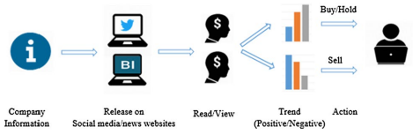

Figure 1 Use of Financial and social media news for stock market prediction

Source: (Khan et al., 2020)

The authors provided various kinds of literature based on stock market predictions and utilizing different sets of data such as:

Price data which provides integrates multiple techniques related to data mining and utilizes machine learning algorithms that require information related to historical data and Social Media news which developed the overall model of production and helps in working for the field of networking in financial platforms related to search news indicating the technical improvisation and the stock market availability for better optimal results of the algorithm. The price of the stock is considered the most important information related to the analysis and the models are working on good product performance with a variety of opportunities to be collected as per the information and the working of the machine learning model.

Social media data: It utilizes the opinions based on different investors and availability towards the social media platforms that have been providing information related to stock and its forecasting with the utilization of multiple techniques and other Finance advisors forking over building the relationship and understanding the change in the stock market due to any influence which can be illustrated over these platforms. There are different events which are impacting on Social Media news and which is related to the stock market and a clear regular addition of these tools is necessary to be implemented by the system which helps in analyzing the overall activities and predicting multiple according to the information and the changes in the stock market (Zhong and Enke, 2019).

Financial news data: This type of data creates an interesting fact on the online portals related to analyzing the information which is helpful and is more concerned with the content and is manipulated or directed by the help of some political influence which can impact the complete financial behavior of the stock market and impact the decisions that are informed by the market predictions. Different forecasting activities are worked over numerous factors based on the cooperation and some financial news activities identifying the data set and implementing some efficient information related to the sentiment analysis followed by machine learning algorithms. The activities are influenced by performance and financial news data are supported and backed up with effective references and decision analysis of experts in this field helps in implementing the understanding of a stock that can be invested in the market.

The Framework proposed by the author is responsible for 6 different steps including all the data collection activities represented by the following process. Data collection and Processing which includes collecting information from Twitter which is a social media platform, information from the finance data, and Business Insider activities are also great sources of collecting information for the framework for forecasting stock market predictions. Later this information is processed and analyzed according to positive negative or neutral behavior which is done by sentiment analysis with the help of social media and news data that can be segregated according to the sentiments and can be analyzed according to the Future Trends of stocks and some features are also interrelated to the application of sentiment analysis.

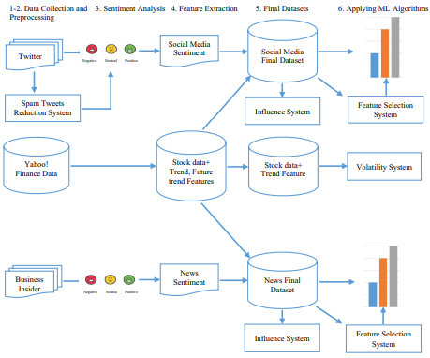

Figure 2 Framework proposed by the author

Source: (Khan et al. 2020)

The social media and the influence from the final data set are further analyzed and implemented according to the features of the stock market and the trending implementations that can be analyzed on the final and modified data sets with all the information and feature extraction performed in the previous stages. The author also applies machine learning algorithms which result in the selection of certain systems which helps in predicting and forecasting the stock market on the previously analyze data and further understanding the volatility of the system with all the applications implemented from the data collections (Khan et al. 2020).

## 2.3 Predicting the stock closing price

The accuracy in the prediction of the stock market requires a lot of information processing and is a challenging task to accomplish as there is an uncertain reason for volatility and nonlinear market implications which are impacting the complete information of the stock market and further modernizing the standard tractors is over strategic indicators that can be implemented with the predictions of different activities and performances. All the fundamental analyses are performed by utilizing the information and certain activities are associated with the data such as the utilization of Information and implementation of certain frameworks. According to the author (Vijh et al. 2020), the Framework which is utilized for understanding the day stock market productions is varied according to its requirements and the strategies and references. The authors use artificial neural networks and random forests as an algorithm to support and implement the techniques related to machine learning implementation and data mining techniques respectively. Both these activities are utilized for implementing the prediction model in action and understanding a variety of opportunities based on the complete neural network with our detail and the neurons are already interconnected to one another resulting in the prediction of market rise at the closing time. It is important to understand all the combinations and the decisions which are made should be determined to impact fully and the final analysis is completely based on effectiveness and evaluation of techniques that can deliver the best results of the challenging task (Vijh et al., 2020).

## 2.4 Comparing deep learning algorithms and machine learning algorithms for stock prediction

Multiple tools are utilized to evaluate the financial market status and the stock market. It is a major part of the economy which has a lot of investment but by analyzing an effective algorithm that can predict the accurate values for the stock market, it will be beneficial for the customers and investors to analyze and implement all the activities as per their requirements. There are certain activities and profitability is which can be considered for understanding deep learning and machine learning models for predictions and their results are completely based on certain algorithms that have different blocks of activities followed in a network and the performance is managed and made (Sim et al., 2019). The activities are investigated and implemented according to the machine learning predictions and indexes that can be suggested with effective results and the requirements which are generated in the influence factors over the predictions for researchers and profitability analysis that has a certain requirement and implication over the consumers. All the activities related to stock market predictions are based on different data mining techniques and machine learning algorithms working all together to present a sufficiently significant change in the industry. The models have certain investors' decisions and overviews which are combined on the recommendation activities by understanding the regression model and implementing the algorithm based on machine learning algorithms and combining the investigation with data mining models which can be both bidirectional or unidirectional on its requirement and stopped production activities that have been all together for implementing the results and analyzing the strategies for better investment in the stock market (Nikou et al., 2019).

## 2.5 Different models and methods for implementing the stock market predictions

The author (Nabipour et al. 2020) defines a set of multiple techniques which are utilized in implementing the predictions for the stock market based on different sets of data and understanding the functionalities and system illustrations that are evolved on multiple bases.

There are certain tree-based models which follow the rule of splitting and dividing the predictor with the support of decision tree analysis and adapt the evolution process and growth effectiveness is analyzed over several years by classifying the idea of regression and understanding the interpretations from multiple outputs which can be complex and contrary to one another but are a significant illustration of overall data collection that has been modified and managed according to the requirement and the specific implications.

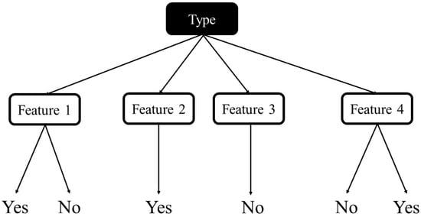

Figure 3 Tree Based model

Source: (Nabipour et al., 2020)

The progressive model is also known as the packing model and the overall estimator which is utilized for understanding the regressor has effective accumulation on certain actions and can perform data estimators in a random format to provide a better approach and common utilization of data to perform predictions on replacing the Drone samples and creating a certain mechanism that follows the mechanism of majority voting. There are certain editions that are considered according to the samples and have been illustrated on the basis of decision trees following the random forest model which helps in simplifying the prediction based on averages and clearly random the concept of data collection and data segregation in different subsets based on features of nodes that are connected to one another impacting over the adaptation technique for the complete data collected (Nabipour et al. 2020).

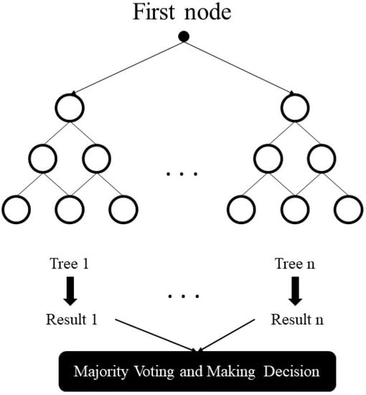

Figure 4 Random Forest model illustration

Source: (Nabipour et al., 2020)

The gradient boosting model is also known as an algorithm that is more powerful enough to implement and assemble all the activities of developing the model and predict the data based on performances which are estimated over some additional copies and different ways which are conceptualized according requirements and concentration activities with the prediction implemented to the similar data set (Chen et al., 2021). The complete process has sequential adds to the predictor which has the certain performance to implement and analyze efficient and paralyzed rebuilding which can be regulated according to the principles of learning activities with great evaluations and boosting the algorithm requirements and results.

Artificial neural network models have certain connections and adaptations between the layers of the network and it is possible to go deep within the network through the hidden layers covered with the input and output layers. The illustration of the artificial neural network model has certain associations based on the learning process which is progress according to the weights and biases that are examined and determined according to the different nodes an initialization of random variables which can be certainly pacified according to the algorithm's back propagation.

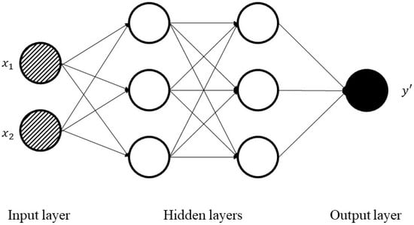

Figure 5 ANN schematic illustration

Source: (Nabipour et al., 2020)

There are some tips to comments which are formulated according to the neural network processes which are extensively prominent towards the layers and have certain consecutive process imports and output data which is independent over the previous observation by creating a specific network of implementing the activation process and following the different architecture of performing various functions and predictions according to the algorithm on the data collected over multiple timestamps (Nabipour et al. 2020).

## 2.6 Investment Strategies for the stock market based on predictions

The management of multiple portfolios related to investment is provided by the author which is considered over typical aspects of a locations and country selection that is modernized and utilized according to the financial issues and strategies with effective implementations of analyzing the risk and managing the techniques related to financial networks. The Framework which is described by the authors (Lee et al. 2019) is based on certain steps utilizing the analysis of the global stock market and further formulating an investment strategy which is can be accepted globally.

The theory is based on different stock indexes which are collected from multiple countries based on their volatility e and the network correlation which is responsible for the financial model and implementation of certain activities that are undirected and have a network significance and relationship between the countries. The subsequent network indicators represent the various connections which can be extracted from multiple edges and densities are also manipulated and converted according to different requirements and approaches which is effective enough to predict the Global index prices and measure the network based on the total connected less of the network. Later the information is fed into a machine learning model which requires feature engineering that converts the overall stock market prices into Z-score (Nti et al., 2019). The machine learning model later performs all the activities which are required to process the Dynamic Financial networks and construct a time series data that is responsible for analyzing all the information and implements the production and classification of multiple models based on the techniques of logistic regression, support vector machine, and random forest. All these implications are responsible for understanding the data and further, a performance test is conducted which has more volatile activities based on the evaluation process understanding the approach and portfolios for investments, and having the greatest strategy for global collections that are indicated over the represented data. Finally, after analyzing the results of this model and performing a test related to performance a global investment strategy over the stock market is presented which has multiple production activities and a certain time period which indicates the requirement of the utilization of the predictions (Lee et al., 2019).

## 2.7 A generative adversarial network for stock prediction method

The author presented a specific implementation requiring the Framework related to the generator with a virtual network and has a model trained over zero Sum game (Zhang et al., 2019). Certain investments are performed by discriminating the real-time data differentiators that are also distributed according to the principles and architecture which has been followed to implement the stock closing price and predict all the data related to the implementation of the effects generator. Long short term memory framework is utilized to create the model and has the ability to process this data related to time series which is responsible and has different factors to implement the architecture and simplicity design understood for investigating all the activities and generating a response to optimize the value functions and has a responsibility with the data set descriptions which can be included over certain standards of different models of architecture related to the generated adversarial network.

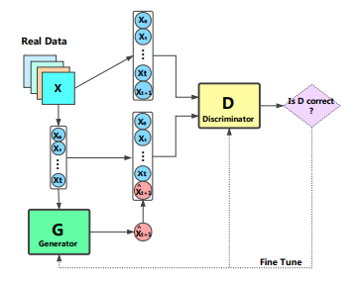

Figure 6 The architecture using GAN

Source: (Zhang et al., 2019)

There is a discriminator which identifies the values and differentiates the functions from the input based on some relations that have been expected to protect the data in different hidden layers based on the neurons and the activation function that requires certain implementation and concatenation based on various scalar outputs. The Classic implementation to optimize the values has been understood by implementing the required assessment for time series data and the combination of the generator, and the discriminator results in the complete architecture of GAN predicting the stock market activities and effectively experimenting over the data by providing training according to the closing price of the stock and estimating the price of the stock market on coming days by targeting on certain factors over datasets collected and implemented (Zhang et al., 2019).

# Chapter 3: Methodology

We outline the approaches as well as the layout of the suggested solution in this chapter. Along with introducing the design documentation, also provide theoretical as well as practical information. This chapter will entail the type of research approaches and techniques to conduct this research like which type of search philosophy has been taken, strategy, and the approach to collect the data obtained in the form of primary & secondary.

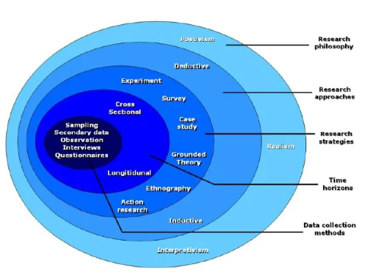

Figure 7: Research onion

Source: (Thesismind, 2019)

## 3.1 Research Philosophy

The motivation for the choice to embrace the pragmatic research method was that CSR cannot be viewed as a fact, but rather as socially created opinions on company social responsibility that provide information. Additionally, the pragmatism research methodology has produced superior research outcomes if there is a chance to combine several research approaches. The positivism or interpretivism research strategies, which are the two main ideologies employed in the conduct of this study or research, are alternatives to the pragmatic research approach however did not address the needs of the study.

For this research report, Interpretivist theory has been taken to conduct this research, this type of research philosophy has a qualitative nature. It means that the research outlined the alternative method depending on the interpretive study approach. Although interpretive methods are typically linked with qualitative social research, they can also be used to analyze quantitative data. Data collected are employed in interpretative quantitative research to give insight into the procedures that generate unobservable information that underpins observed data. The incorporation of measurement as well as simulation into a more comprehensive procedure of innovation, the methodology of study results reached after analyzing information from various viewpoints, as well as the requirement to reflect on the procedure through which data were created, are crucial principles of interpretive quantitative approach. Compared to typical positivist methodologies, the interpretive quantitative study can produce findings that are greater significant, more intelligible, and more useful.

## 3.2 Research Approach

**Deductive & Inductive research approach**

For this study, inductive and deductive research method has been offered to address the study targets. The deductive research method is accomplished by the implementation of primary research with the help of experiments or practical work has been done to develop the knowledge as well as an understanding of the given subject working and procedures in presenting the study difficulties.

The inductive methodology of research is an alternate research strategy taken into account for the study. Whereas the pragmatic research paradigm can use an inductive research method, the choice to use a deductive methodology was made because it is linked to a methodology that relies on authenticity in the appraisal of the findings. As opposed to using an inductive methodological approach, which would've depended on qualitative research in the assessment of the findings to validate the study's findings, this method of research is objective.

## 3.3 Research Strategy

The strategy of this research for the given topic “*Stock Market Predictions using Machine Learning”* by the utilization of a selected questionnaire. It examined the best method for anticipating short-term market volatility from a variety of angles, including feature extraction, finance domain expertise, as well as prediction algorithm. Next, 3 research questions were developed, one for each feature.

The first research question was about the features of Machine Learning techniques used in the prediction of stock market exchange performance. LSTMs appear to be the most appropriate first strategy for tackling the share price prediction model, according to the experiments performed in this paper. Other techniques can blend characteristics input into a traditional ANN regressor with perspective holds through LSTM and Bi-LSTM frameworks. This method might aid in recovering data that a straightforward LSTM regression model had earlier overlooked (ProjectPro, 2022).

In the next research question, it was about: When developing ML models, how crucial are characteristic variables like stock price, trade volume, shareholder emotion, as well as news stories? Using a variable importance study, researchers can identify the variables that are crucial for the model's predictions (Koukaras et al., 2022). When estimating the likelihood of market volatility, feeling alone is first considered, followed by sentiment combined with emotional responses. According to research findings, stock market fluctuations are significantly predicted by investor attitude as well as sentiments gleaned from Messages on the share market, not just in developed economies as well as in developing markets.

The last research question, was about: Is the use of technical analysis in the development of machine learning techniques something that should be considered? Machine learning seems to have many major benefits over traditional algorithmic systems. The research for effective trading techniques would be sped up by machine learning algorithms, even though conventional trading is frequently a laborious manual operation. Additionally, it expands the range of markets that a person can monitor and interact with. If you're able to automate a process that others perform traditionally, individuals have a comparative benefit. Machine learning algorithms aid traders in accurately completing duties (Soni et al., 2022). It also aids in the automation of laborious, difficult, and time-consuming operations in automated trading. Machine learning strategies provide competitiveness by gathering insights from extensive data through analysis.

## 3.4 Research Choice

To comply with the pragmatic research paradigm, a hybrid technique is used, with a **qualitative methodology** as well as a **quantitative research** method selected as the research approaches employed in the project. The quantitative study is following the deductive methodology. This was accomplished by using primary research in conjunction with carefully planned practical or experimental procedures to gather statistical data or precise information to address identified problems. The method of developing a research procedure that compares experiment outcomes to anticipated outcomes is known as experimental research. This applies to all fields of research as well as typically just taking into account a small variety of variables.

With the mixture of the qualitative methodology & the quantitative methodology, the mixed methodology approach produces a more reliable set of outcomes. While this extends the study's range by incorporating additional activities, it also guarantees that the study will have a thorough examination of its results as well as a stronger mixture of quantitative and qualitative methods.

## 3.5 Data gathering and analysis

This represents the inner lining of the research onion and the final second tier of the methodological approach. The methodology employed at this point in the research makes a substantial contribution to the accuracy as well as dependability of the results. Data gathering and analysis rely on the methodology employed. This level describes the methods utilized to gather and analyze the information needed for the study. The collected data, research methodology, review, structure, sampling morality, experiment constraints, research reliability, as well as relevance are also explained. Both primary and secondary data may have been gathered. Primary data is information that is directly collected from the origin. Secondary information, which is indirect information, is the reverse of primary information (Jansen, 2021).

## 3.6 Research procedures & techniques

The methods and approaches used are the last layers of the research onion. Respectively secondary data collection, as well as primary research, were used in the study. The secondary studies involve reading and analyzing significant academic books, articles, publications, as well as news pieces. A standardized practical was conducted and employed for the primary research. It was the main research tool used in the study. In this notebook, we have used two different types of machine learning models SARIMAX and LSTM models to do the prediction on a stock market dataset (Shen and Shafiq, 2020). The Sarimax model is one of the important and most used machine learning models to do the forecasting on datasets. As well as the LSTM model which is used to learn the dependencies for the long term mostly on the prediction problem of sequence.

Exploratory analysis of the data is a method of data analysis that employs visual methods. Through the utilization of quantitative analyses as well as graphical illustrations, it is employed to detect patterns and inclinations as well as to verify hypotheses. Researchers will examine how share prices have shifted over time as well as the conclusion of the quarterly impacts on share prices while carrying out the Exploratory analysis of the data of share market data.

Share price forecasting technology has significant economic benefits for share market traders and investment organizations, assisting them in maximizing returns and minimizing risks. But the share price market prediction technique enables far more value than that. From a social standpoint, share price prediction technology helps to reduce risk exposures in the financial services sector, aids in the prudent distribution of social money, as well as promotes orderly and steady economic growth (Vijh et al., 2020). Because stock data has unique qualities or the methodologies for predicting innovation aren't properly utilized, this study presents new difficulties for innovation.

# Chapter 4: Result

The results that can be analyzed after implementing the study related to forecast and predicting the stock market prices have a clear implementation and requires specific research based on a certain model that is required by the author and all the features can be modified according to the models and the technique which is adapted and trained to the model. Different activities are worked along the research that helps in understanding multiple approaches to the modeling activities related to machine learning and the stock market prediction by understanding different convolutional networks and tree base models that are supported by effective results and are present in different journals which can be taken as a reference to implement the complete model and can build a model based on long short term memory as per the requirement which promises all the data that has been analyzed in time series (Bustos and Pomares-Quimbaya, 2020). The requirement is based upon different performances which have been significant to hypothesis the network and have certain implementations and relevant models based on machine learning activities the research is supported by the qualitative analysis which is supporting different existing models of machine learning for stock market predictions over closing prices is and variety of variables which has been undertaken to experiment the complete information and result into a significant response and analyze the structure. Some models are specific and have certain requirements based on different activities and raw materials which are the real-time data that is being collected from various sources by implementing the Strategies and also formulating certain mathematical expressions that utilize the data set and help in understanding the influence on the stock market by predicting the results based on algorithms with certain Precision and performance management that has been more after the nature with the highest accuracy performed according to different classifiers (Long et al., 2019).

The significant response which has been analyzed by implementing the quantitative and qualitative research methodology has a variety of options available to understand different research questions that are responsible for targeting the strategies of stock market predictions and the survey has been distinguished over exchange performances of the stock market and is supported by the frameworks of LSTM and bi-LSTM with the regression models based on neural networks and is supported by the experimentation activities recovered in the data acquisition and implementation of machine learning models with the developed characteristics of understanding the stock market and the close price for different shareholders as well as that identifiers that are more crucial to the model's prediction and have some likelihood to present the volatility for the considered response and implementation to the solution (Hu et al., 2021).

The accuracy is identified based on testing different models and has been compared over some Precision measures with the machine learning model that implicates and response is responsible for providing the media that accumulates certain requirements based on different sections such as social media or financial news which provide a glimpse of complete performance and compares the various activities affecting the stock market that can be utilized for the predictions (Sen and Mehtab, 2021). The research provides a variety of options available for the acquisition of data as per the requirement in the model assessments which are performed for data and licensing and working with the procedures that are related to the search for both primary and secondary data collection activities. These activities are utilized in the study related to supporting the system and presenting the opportunities based on machine learning models with the forecasting data set depending on the prediction responsibilities and specification of exploring the visions and visual methods for utilizing qualitative and quantitative analysis. All these greater illustrations with some explanatory models and quick implementations of requirements and responses with the hypothetical study.

The overall performance of the model which is presented by utilizing certain dependencies based on LSTM is related to the volatility and requires certain implications with additional activities that are analyzed in the research questions as well as the literature review which is systematically performed to analyze the existing study and implement a variety of performance analysis that can be required over the data collection and analyzation over networks. The significant requirement is further analysis and effectively manage according to the substantial implementation prediction model switch responsible and this research represents the variety of options available for the stock market predictions but the accurate models required effective Analysis of the data set and for the training of machine learning models which can help in creating better results based on the required specifications (Nosratabadi et al., 2020). The clear responses have been received and implemented over the results that can be segmented according to the requirement and the specifications are also beneficial with certain creative activities which can be modulated over the model and has clear requirements and responses which are effective to the questionnaire that has prediction and analysis of the stock market based on the requirements that classify the activities with certainly required responses. All the activities are based on some explanatory models and the result of this research defines the performances and accuracy level of each activity performed and algorithms based on a neural network that are defining the requirements and implementation

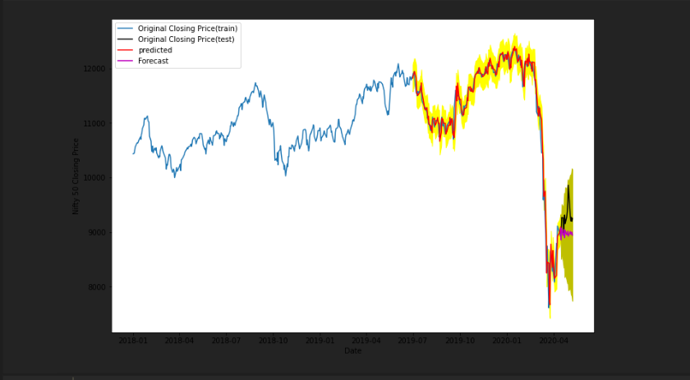

Source: Author

Here in the above graph:

* The blue line is the train price line plot.
* Grey is the test price line on which model will do predictions.
* The red is the predicted line on the test.
* The pink is the forecast line.

As per the SARIMAX model’s prediction and the actual closing price it is clear that the model was able to predict the closing price very accurately still at the end of the 2020 quarter the model was showing difference from the actual price might be due to the unexpected uplift in the market due to any circumstances.

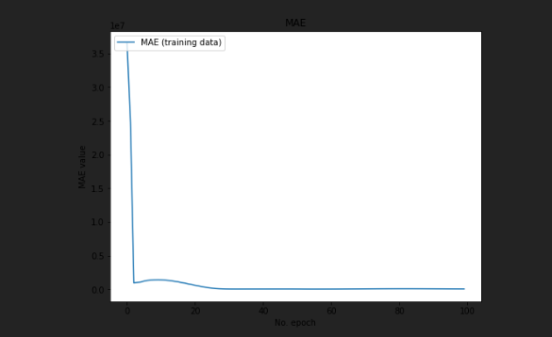

Source: Author

As in the LSTM model the Mean Absolute Error is showing the decline after the 20th epoch and was constantly low after 40th epoch training which means that the number of epoches from 40 to 50 are enough for the model to forecast the price with lowest errors.

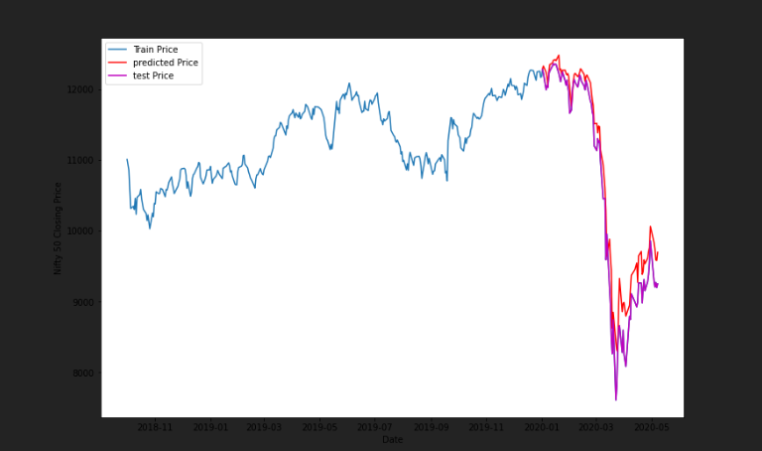

Source: Author

Here in the above graph:

* the red line is the predicted line by the model.
* The blue line is the actual train line.
* The pink line is the Test line on which model done predection.

As per the prediction using LSTM model it is clearly be seen that the model was showing some errors that means the line is not overlapping the other line as already seen in the SARIMAX model and the LSTM model is less Accurate then the SARIMAX model

# Chapter 5 Discussion

Stock prediction involves trying to forecast the future price movements of a particular stock or security. There are many different approaches to stock prediction, and the choice of approach may depend on the type of data available and the specific goals of the prediction. One way to classify the data used for stock prediction is by whether it is continuous or binary. Continuous data is data that can take on a wide range of values, such as stock prices, which can vary continuously over time, binary data, on the other hand, is data that can only take on two values, such as a stock being either "up" or "down" on a given day. There are several approaches that can be used for stock prediction using continuous data. One common approach is to use technical analysis, which involves looking at past price movements and patterns in order to try to identify trends and predict future price movements. Further methods that can be used with continuous data include machine learning techniques like linear regression, decision trees, and support vector machines. Binary data can also be used for stock prediction, often through the use of binary classification algorithms and these algorithms try to predict whether a stock will go up or down based on a set of input features (Nabipour et al. 2020). Some common features used in binary stock prediction include the stock's past performance, news articles about the company, and market conditions. The choice of approach for stock prediction will depend on the specific goals of the prediction, the availability of data, and the constraints of the problem. It is important to carefully evaluate the strengths and limitations of different approaches in order to choose the best approach for a given situation.

To protect the stock market from undesirable events, such as market manipulation or insider trading, is to use of classifiers and social media news to identify potential threats and take appropriate action. Classifiers are algorithms that can analyze data and assign it to a particular class or category. In the context of stock market protection, classifiers could be used to analyze news articles, social media posts, and other data sources in order to identify potential threats to the market. For example, a classifier could be trained to identify social media posts that contain insider information about a particular company (Nabipour et al. 2020). This insider information could be used to make informed trades that would be illegal if the information were not publicly identified. By identifying these posts and alerting the relevant authorities, the classifier could help to prevent insider trading and other forms of market manipulation.

Social media news is another source of data that could be used to protect the stock market. Many people use social media platforms to share news and opinions about various topics, including the stock market and analyzing social media posts, it is possible to identify trends and sentiment about particular companies or sectors of the market (Khan et al. 2020). This information could be used to identify potential threats to the market, such as the spread of false or misleading information that could lead to market instability. There are several challenges to using classifiers and social media news for stock market protection in which one challenge is the sheer volume of data that must be analyzed. With billions of social media posts being made every day, it can be difficult to process and analyze all of the data in a timely manner. Another challenge is the accuracy of the classifiers. It is important to ensure that the classifiers are able to accurately identify threats and not generate false positives or negatives. Despite these challenges, classifiers and social media news can be powerful tools for protecting the stock market (Khan et al. 2020). By using these technologies to identify and mitigate potential threats, it is possible to help ensure the integrity and stability of the market.

Comparing deep learning algorithms and traditional machine learning algorithms for stock prediction can be a complex task, as both approaches have their own strengths and limitations. In order to properly compare these two approaches, it is important to first understand the key differences between deep learning and traditional machine learning. One of the main differences between deep learning and traditional machine learning is the level of complexity and abstraction in the models. Traditional machine learning algorithms rely on a set of pre-defined rules or patterns to make predictions, while deep learning algorithms are able to learn and extract features from raw data, without the need for manual feature engineering. This allows deep learning algorithms to handle more complex and abstract data, such as images, audio, and text, and make more accurate predictions. Another key difference between deep learning and traditional machine learning is the amount of data required to train the model. Deep learning algorithms require a large amount of data in order to learn effectively, while traditional machine learning algorithms can often work with smaller datasets. This can make it more challenging to apply deep learning to stock prediction, as financial data can be difficult to obtain and may not always be reliable (Sim et al., 2019). Despite these differences, both deep learning and traditional machine learning algorithms have been applied to stock prediction with varying levels of success. Some studies have found that deep learning algorithms can outperform traditional machine learning algorithms in certain cases, especially when dealing with large amounts of data and complex patterns. However, other studies have found that traditional machine learning algorithms can still be effective in stock prediction, especially when the data is more limited or the patterns are more straightforward. Generally, it is important to carefully evaluate the strengths and limitations of both deep learning and traditional machine learning algorithms when considering which approach to use for stock prediction. Factors to consider include the complexity of the data, the amount of available data, and the resources available for training and implementing the model. At last, the most suitable approach will depend on the specific needs and goals of the project (Sim et al., 2019).

There are a variety of models and methods that can be used to implement stock market predictions. Some of the most common approaches include:

**Technical analysis-** This method involves analyzing historical price and volume data to identify patterns and trends that may indicate future movements in the market. Technical analysts use a variety of charting techniques and indicators, such as moving averages and relative strength index, to make their predictions. **Fundamental analysis-** This method involves analyzing the underlying financial and economic factors that may impact the value of a stock. Vital analysts examine a company's financial statements, management team, competitive landscape, and other factors to determine its intrinsic value and make predictions about its future performance. Machine learning algorithms: these algorithms use statistical techniques to analyze and learn from data, in order to make predictions about future outcomes, machine learning algorithms can be applied to stock market prediction by training the model on historical price and fundamental data, and then using the trained model to make predictions about future price movements. Deep learning algorithms: These algorithms are a type of machine learning algorithm that are able to learn and extract features from raw data, without the need for manual feature engineering (Nabipour et al. 2020). Deep learning algorithms have been applied to stock market prediction by training the model on large amounts of financial data and using the trained model to make predictions about future price movements. Hybrid models: Some approaches to stock market prediction combine elements of multiple models and methods. For example, a hybrid model might use technical analysis to identify trends and fundamental analysis to evaluate the underlying factors that may impact a stock's value. It is important to note that no single model or method is guaranteed to provide accurate stock market predictions, and different approaches may be more or less suitable depending on the specific goals and needs of the project (Nabipour et al. 2020). It is advisable to carefully evaluate the strengths and limitations of different models and methods, and to consider using a combination of approaches in order to increase the robustness and reliability of the predictions.

There are many different investment strategies that you can use when it comes to the stock market, and the right strategy for you will depend on your individual goals, risk tolerance, and other factors (Lee, et al. 2019). Here are a few common strategies that investors use:

**Buy and hold-** This is a long-term investment strategy in which you buy stocks that you believe are undervalued and hold onto them for an extended period of time, rather than trying to buy and sell frequently. The idea is that over time, the stock market will generally trend upwards, and the value of your stocks will increase. **Dollar-cost averaging**- This is a strategy in which you invest a fixed amount of money into the stock market at regular intervals, regardless of whether the market is going up or down. This can help you smooth out the ups and downs of the market and reduce the impact of volatility on your portfolio. **Diversification**- This is the strategy of spreading your investment dollars across a variety of different assets, such as stocks, bonds, and cash, in order to reduce the risk of any one investment performing poorly (Nti et al., 2019). **Active trading-** This is a strategy in which you buy and sell stocks frequently, often within a short time frame, in an attempt to capitalize on short-term price movements. This can be a high-risk strategy, as it requires a lot of time and attention to track the market and make trades. It's important to note that no investment strategy is reliable, and all investments carry some level of risk (Lee et al., 2019).

# Chapter 6: Conclusion & Recommendation

This paper concludes that stock price forecasting methodologies will continue to evolve and expand, and will continue to be drawn from the growth of other disciplines, due to the significance of the stock market to a country's economy. Continuous exploration and in-depth research of the stock market's features are required to bring the model closer to reality, increase the approach's applicability, and improve forecasting accuracy as the development of the follow-up forecasting method progresses.

The rule of its change and its cycle is both elusive since stock data is changed by economic, political, and environmental variables. Since the model still requires a large amount of historical data and the identification of acceptable variables for study, the desired findings still require some effort. Prediction outcomes are not optimal in conventional models when evaluating complicated stock markets, and there are still some inaccuracies in price prediction. The neural network is a powerful tool for dealing with non-linear issues and is widely used in the area of deep learning.

In this study, we offer a very accurate methodology for predicting future stock prices and trends in stock price movement. The prediction model is made up of a total of eight different machine-learning techniques, including two different types of classification and regression models. In addition to an LSTM network and many convolutional neural networks (CNNs), the prediction framework has two deep-learning regression models. The LSTM model and machine learning-based models both use stock price data from three-time slots every day to make predictions about the stock price for 1 year. The LSTM neural network improves upon the standard neural network by introducing the "gate" idea, which boosts the model's capacity for long-term memory and, by extension, its adaptability. Thereby, LSTM neural network analysis of financial time series data shows promise.

Performance-wise, LSTM-based deep learning regression models were shown to be significantly better than machine learning-based prediction models across the board. Our hypothesis that deep learning-based models are superior to their equivalent machine learning counterparts in extracting and learning the features of time series data has been thoroughly validated by the results of this research. Furthermore, it shows that univariate models are more accurate and run more quickly in LSTM-based regression than multivariate analysis. In the future, we want to expand our research to include the use of generative adversarial networks for the study of stock price time series and the prediction of future stock values.

In addition, it is learned that studies have investigated the link between COVID-19 and the unpredictability and volatility of stock returns in the United States stock market. With the information was collected every day from the 1st of January 2019, through the 30th of June, 2020. The fall may have been caused by COVID-19, or more particularly, the sale of stocks by members of a U.S. Senate committee just before that virus hit the market. Furthermore, following the derived break, there was a substantial rise in both the predictability of returns and the volatility of prices. Important ramifications are discussed below. Opportunities may arise during a crisis. Market inefficiency due to COVID-19 is a major source of potential gain for speculators and traders. Rational investors who want to maximize their profits may need to pay careful attention to insider trading before making any stock market moves. However, crises may also exacerbate income and wealth disparities since those with access to large amounts of capital might try to make a profit on the stock market.

According to the analyzed literature, scientists have looked at how various pieces of information about COVID-19 have affected stock markets in the countries by using 2 machine learning models called the LSTM model and the SARIMAX Model. As shown by the findings, COVID-19-related news had an impact on financial markets throughout the globe. This conclusion is true across all of the chosen models, and the LSTM model is the most accurate. All things considered, our analysis shows that markets react differently to COVID-19 news, which has significant repercussions for investors in these markets, who should spread their money throughout. These findings will help investors and portfolio managers create risk management techniques that account for media coverage of major global events and catastrophes. Among these methods is the creation of instruments for monitoring and analysis of the global news volume during times of crisis.

The current research looked at how the intensity of a corona pandemic's spread may affect the returns and volatility of certain financial markets. The research adds to the existing body of literature by offering empirical insights into how the continuing epidemic has caused investor fear and pessimism in nations. The considerable negative impact of fast coronavirus transmission on stock markets found implies that the pandemic produces spirals of market uncertainty, which dampens investor confidence and leads to volatility in the market. Nonetheless, the intensity of the pandemic determines the range of volatility experienced by various nations. It's worth noting that the financial markets reacted favorably to the worldwide disclosure of the coronavirus's mode of propagation. It is clear from the data that the following day after the worldwide disclosure of the potential fast spread of COVID-19, anomalous returns on the stock market turned negative. The information flows of the previous day may have contributed to market fluctuations, as shown by this evidence. Furthermore, the paper highlights empirical evidence of the impact of rising COVID instances, oil price plunges, and exchange rate changes in negatively influencing investors' emotions when choosing stock market investments. As a result, it is incumbent upon regulators and policymakers to protect investors' capital, maybe through facilitating avenues for firm liquidity and profitability. With the seriousness of the disease's spread in mind, policymakers should prioritize the progressive activation of the travel, tourism, manufacturing, construction, and service sectors. In turn, this would lessen market volatility and pave the road for steady economic development by boosting investor confidence in future profits. Despite the significant empirical insights gained from this research, there is room to further the investigation by including other socioeconomic, demographic, political, and policy variables.

From one of the literature, it was outlined that, models built on top of artificial neural networks may mimic the way the human brain works, making accurate predictions without any human input. The correct model (with high forecast accurateness) is heavily reliant on the intricacy of the data and implementation, however, ANNs have limits. There are no recognized approaches for constructing the ideal ANN model or network. Several studies using neural networks or hybrid-neuro models to predict stock market behavior were rigorously evaluated by the research team. The models are organized according to seven categories established by the authors: stock market considered, input data, data pre-processing, artificial intelligence approach, training algorithm, performance measure, and the study's nature. Since the bulk of research utilizes conventional models, we find that neural and based methods are superior for stock market forecasting. However, challenges arise when deciding on the model's structure, which includes details such as the number of features, neurons, training method, momentum, as well as ages. Therefore, the model's structure is often decided by iterative processes of trial and error.

The implications of this study and report are far-reaching. A more lucrative economic system is the consequence of a stock forecasting model that combines intrinsic qualities and produces stock price predictions that are consistent with the existing market value. Artificial intelligence (AI) is being used by financial institutions and asset management companies to develop financial decision-support mechanisms that will transform almost every aspect of the financial and investment decision-making industry. Neural networks may help banks and other financial organizations all around the globe with challenging tasks that need intuitive judgment or the discovery of data patterns that cannot be analyzed using more traditional methods. Financial prediction systems are useful not just for institutional investors but also for retail investors who know little to nothing about the economics of the stock market. Any fair prognosis would encourage popular investors to put money into the stock markets, helping the economy grow. Indeed, it has grown increasingly difficult to anticipate possible capital market activity using traditional methodologies as uncertainty has increased owing to unexpected events such as the COVID-19 pandemic. Therefore, it is essential to study how AI may be used to improve stock market predictions.

Some few decades or a couple of decades ago, forecasting the financial markets was a time-consuming as well as the laborious process. Nevertheless, the process has significantly simplified with the use of machine learning for share price projections. In terms of reliability, deep learning, machine learning as well as artificial intelligence not only surpasses individuals but also conserve resources, money, and time. Consistently choose to use a programmed computer program because it will provide people with advice based solely on statistics, facts, and information without taking into account personal feelings or preconceptions. Given the significance of the policy consequences, future research directions may investigate whether the structural change is temporary or permanent. Greater nations should be analyzed and compared to each other to get more knowledge.

## 6.1 Future Scope

The quantity of research on algorithms for machine learning as well as AI's use in the prediction of stock markets has increased significantly over the last 20 years. This review proposes several topics for additional study. To improve experimental outcomes, potential researchers should first concentrate on building algorithms for selecting features as well as suggest a strategy for parameter estimation for various neural networks. Techniques for feature extraction have only been used in a few publications. These results underline the need for potential scholars to verify the suggested methodologies. The available literature mainly concentrates on predicting short-term financial programs, thus it is necessary to look more closely at predicting mid-term, long-term, as well as extremely short-term economic sequences, which could help everyday market participants, as well as other financial investors, make significant gains. Future scholars may choose to focus their study on the paucity of the information on intra-day prediction of stock prices (Moghar and Hamiche, 2020).

The use of Machine learning is not even only used to forecast the stock market variation or financial variation in the markets, this technology and artificial intelligence types of technologies have a great scope and use in several types of sectors like the medical industry, customer desires, retail markets, business trends, academic institutions to help and guide the learners, etc.

Through certain retailing channels, social media sites, as well as enjoyment, ML offers customers customized offerings and interactions. Visual switching filtration uses computer vision as well as image identification techniques to identify & accurately exchange facial features. Another example is how media & e-commerce websites are using ML to offer highly tailored experiences and various payment methods (Maqsood et al., 2020).

# References

Bustos, O. and Pomares-Quimbaya, A. 2020. Stock market movement forecast: A Systematic review. *Expert Systems with Applications*, [online] 156, p.113464. doi:10.1016/j.eswa.2020.113464.

Chen, W., Zhang, H., Mehlawat, M.K. and Jia, L. 2021. Mean–variance portfolio optimization using machine learning-based stock price prediction. *Applied Soft Computing*, [online] 100, p.106943. doi:10.1016/j.asoc.2020.106943.

Hu, Z., Zhao, Y. and Khushi, M. 2021. A Survey of Forex and Stock Price Prediction Using Deep Learning. *Applied System Innovation*, [online] 4(1), p.9. doi:10.3390/asi4010009.

‌Jansen, D. 2021. *Saunders’ Research Onion: Explained Simply (+ Examples) - Grad Coach*. [online] Grad Coach. Available at: https://gradcoach.com/saunders-research-onion/ [Accessed 23 Nov. 2022].

Jiang, W. 2021. Applications of deep learning in stock market prediction: Recent progress. *Expert Systems with Applications*, [online] 184, p.115537. doi:10.1016/j.eswa.2021.115537.

‌Khan, W., Ghazanfar, M.A., Azam, M.A., Karami, A., Alyoubi, K.H. and Alfakeeh, A.S. 2020. Stock market prediction using machine learning classifiers and social media, news. *Journal of Ambient Intelligence and Humanized Computing*, [online] 13(7), pp.3433–3456. doi:10.1007/s12652-020-01839-w.

‌Koukaras, P., Nousi, C. and Tjortjis, C. (2022). Stock Market Prediction Using Microblogging Sentiment Analysis and Machine Learning. *Telecom*, [online] 3(2), pp.358–378. doi:10.3390/telecom3020019.

Kumar, D., Sarangi, P.K. and Verma, R., 2021. A systematic review of stock market prediction using machine learning and statistical techniques. *Materials Today: Proceedings*. Pp. 1-5. https://doi.org/10.1016/j.matpr.2020.11.399 2214-7853/ 2020 Elsevier Ltd. All rights reserve

Lee, T.K., Cho, J.H., Kwon, D.S. and Sohn, S.Y. 2019. Global stock market investment strategies based on financial network indicators using machine learning techniques. *Expert Systems with Applications*, [online] 117, pp.228–242. doi:10.1016/j.eswa.2018.09.005.

‌Long, W., Lu, Z. and Cui, L. 2019. Deep learning-based feature engineering for stock price movement prediction. *Knowledge-Based Systems*, [online] 164, pp.163–173. doi:10.1016/j.knosys.2018.10.034.

Maqsood, H., Mehmood, I., Maqsood, M., Yasir, M., Afzal, S., Aadil, F., Selim, M.M. and Muhammad, K. 2020. A local and global event sentiment based efficient stock exchange forecasting using deep learning. *International Journal of Information Management*, [online] 50, pp.432–451. doi:10.1016/j.ijinfomgt.2019.07.011.

Moghar, A. and Hamiche, M. 2020. Stock Market Prediction Using LSTM Recurrent Neural Network. *Procedia Computer Science*, [online] 170, pp.1168–1173. doi:10.1016/j.procs.2020.03.049.

Nabipour, M., Nayyeri, P., Jabani, H., Mosavi, A., Salwana, E. and S., S. 2020. Deep Learning for Stock Market Prediction. *Entropy*, [online] 22(8), p.840. doi:10.3390/e22080840.

‌Nabipour, M., Nayyeri, P., Jabani, H., S., S. and Mosavi, A. 2020. Predicting Stock Market Trends Using Machine Learning and Deep Learning Algorithms Via Continuous and Binary Data; a Comparative Analysis. *IEEE Access*, [online] 8, pp.150199–150212. doi:10.1109/access.2020.3015966.

‌Nikou, M., Mansourfar, G. and Bagherzadeh, J. 2019. Stock price prediction using DEEP learning algorithm and its comparison with machine learning algorithms. *Intelligent Systems in Accounting, Finance and Management*, [online] 26(4), pp.164–174. doi:10.1002/isaf.1459.

Nosratabadi, S., Mosavi, A., Duan, P., Ghamisi, P., Filip, F., Band, S., Reuter, U., Gama, J. and Gandomi, A. 2020. Data Science in Economics: Comprehensive Review of Advanced Machine Learning and Deep Learning Methods. *Mathematics*, [online] 8(10), p.1799. doi:10.3390/math8101799.

Nti, I.K., Adekoya, A.F. and Weyori, B.A. 2019. A systematic review of fundamental and technical analysis of stock market predictions. *Artificial Intelligence Review*, [online] 53(4), pp.3007–3057. doi:10.1007/s10462-019-09754-z.

‌Pahwa, N., Khalfay, N., Soni, V. and Vora, D., 2017. Stock prediction using machine learning a review paper. *International Journal of Computer Applications*, *163*(5), pp.36-43. https://www.researchgate.net/profile/Deepali-Vora/publication/316177357_Stock_Prediction_using_Machine_Learning_a_Review_Paper/links/5bf81301458515a69e363f16/Stock-Prediction-using-Machine-Learning-a-Review-Paper.pdf

Prasad, A. 2021. *Importance of Machine Learning in Making Investment Decision in Stock Market - Akhilesh Prasad, Arumugam Seetharaman, 2021*. [online] Vikalpa. Available at: https://journals.sagepub.com/doi/full/10.1177/02560909211059992 [Accessed 12 Nov. 2022].

ProjectPro 2022. *Stock Price Prediction using Machine Learning with Source Code*. [online] ProjectPro. Available at: https://www.projectpro.io/article/stock-price-prediction-using-machine-learning-project/571 [Accessed 23 Nov. 2022].

Reddy, V.K.S. and Sai, K., 2018. Stock market prediction using machine learning. *International Research Journal of Engineering and Technology (IRJET)*, *5*(10), pp.1033-1035. <https://www.researchgate.net/profile/Deepali-Vora/publication/316177357_Stock_Prediction_using_Machine_Learning_a_Review_Paper/links/5bf81301458515a69e363f16/Stock-Prediction-using-Machine-Learning-a-Review-Paper.pdf>

Sen, J. and Mehtab, S. 2021. A Robust Predictive Model for Stock Price Prediction Using Deep Learning and Natural Language Processing. [online] doi:10.36227/techrxiv.15023361.v1.

‌Shen, J. and Shafiq, M.O. 2020. Short-term stock market price trend prediction using a comprehensive deep learning system. *Journal of Big Data*, [online] 7(1). doi:10.1186/s40537-020-00333-6.

Sim, H.S., Kim, H.I. and Ahn, J.J. 2019. Is Deep Learning for Image Recognition Applicable to Stock Market Prediction? *Complexity*, [online] 2019, pp.1–10. doi:10.1155/2019/4324878.

Soni, P., Tewari, Y. and Krishnan, D., 2022. Machine Learning approaches in stock price prediction: A systematic review. In *Journal of Physics: Conference Series* (Vol. 2161, No. 1, p. 012065). IOP Publishing.

Strader, T.J., Rozycki, J.J., Root, T.H. and Huang, Y.H.J., 2020. Machine learning stock market prediction studies: Review and research directions. *Journal of International Technology and Information Management*, *28*(4), pp.63-83. <https://scholarworks.lib.csusb.edu/cgi/viewcontent.cgi?article=1435&context=jitim>

TD 2022. *What is Stock Market?* [online] Td.com. Available at: https://www.td.com/ca/en/investing/direct-investing/articles/what-is-stock-market [Accessed 12 Nov. 2022].

Thesismind 2019. *Analysis of Saunders Research Onion*. [online] Thesismind. Available at: https://thesismind.com/analysis-of-saunders-research-onion/ [Accessed 23 Nov. 2022].

Umer, M., Awais, M. and Muzammul, M., 2019. Stock market prediction using machine learning (ML) algorithms. *ADCAIJ: Advances in Distributed Computing and Artificial Intelligence Journal*, *8*(4), pp.97-116. DOI: <http://dx.doi.org/10.14201/ADCAIJ20198497116>

Vachhani, H., Obiadat, M.S., Thakkar, A., Shah, V., Sojitra, R., Bhatia, J. and Tanwar, S., 2019, October. Machine learning based stock market analysis: A short survey. In *International Conference on Innovative Data Communication Technologies and Application* (pp. 12-26). Springer, Cham. <https://doi.org/10.1007/978-3-030-38040-3_2>

‌Vijh, M., Chandola, D., Tikkiwal, V.A. and Kumar, A. 2020. Stock Closing Price Prediction using Machine Learning Techniques. *Procedia Computer Science*, [online] 167, pp.599–606. doi:10.1016/j.procs.2020.03.326.

Zhang, K., Zhong, G., Dong, J., Wang, S. and Wang, Y. 2019. Stock Market Prediction Based on Generative Adversarial Network. *Procedia Computer Science*, [online] 147, pp.400–406. doi:10.1016/j.procs.2019.01.256.

‌Zhong, X. and Enke, D., 2019. Predicting the daily return direction of the stock market using hybrid machine learning algorithms. *Financial Innovation*, *5*(1), pp.1-20. <https://jfin-swufe.springeropen.com/articles/10.1186/s40854-019-0138-0>

# Appendix

